**Grinding Instructions**

**Grind Tool Warmup**

- Turn on DI Water and Non-Potable DI Water (valves located on wall in back of Grind tool)

- Rinse chuck table - Hit Work-Set, then hit Chuck Blow On/Off

- Hit Warmup button on screen, set time to 30 minutes, hit Start

**Grind** **Tool Operation**

- After tool is done with warmup cycle (30 mins), hit Stop and Exit

- Hit Initial and click Start, then Exit when complete

- Hit Gauge/Zero Point button (result should be ~ -900 +/- 5um)

**Monitor Processing**

- Pre-measure Silicon monitor (SIGRINDxxx) on granite table (see procedure below)

- Select List

- Highlight Recipe 3 : Step 1 Course_Mon

- Click select to activate Recipe 3

- Input Original Thickness and Final Target Amount **(120 um thinner than original thickness)**, then hit Save

- Hit Work-Set, then Spindle On/Off and Grind Water On/Off to turn the spindles and water on

- Hit Chuck Blow On/Off to turn on, the hit it again to turn it off.

- Put wafer in center of chuck (surface to be polished facing UP, for monitors the SHINY side should be facing UP)

- Hit Chuck Vac On/Off to turn vacuum on

- Hit Workset and then Start

- Write down incoming thickness (IPG: Work Thik) from grind tool in notebook/Grind worksheet

- At end of cycle, write down the Post Grind thickness. Then hit Alm/Clr button

- Use DI water to hose off the inside of the tool as well as the wafer on the chuck

- Hit Chuck Vac On/Off to turn off the vacuum, then hit Chuck Blow On/Off and remove wafer. Rinse the back side of it off with DI water, as well as the chuck.

- After wafer has sufficiently dripped dry, place in cleaner

- Post-measure Silicon monitor on granite table (see procedure below)

MRL Track : Initiator input steps : How to follow :

a). Si Substrate (product wafer) before bonding.

Found in one of two places:

1. The FRONTSIDE TSV PROCESSING steps further back in MRLTRACK
2. The Wafer and Inspection Step right near the beginning of the route

c). Confirm TSV depth (initiator provided)

g). Confirm post CMP target (usually 10um thinner than value in c).

f). Should be a CMP removal of 35um

e). Should be value g) plus 35um

d). Should be grind removal [Value a) minus value e)]

IF VALUES ARE MISSING, PUT THE LOT ON HOLD AND CONTACT THE INITIATOR.

CONFIRM ALL THE MATH MAKES SENSE.

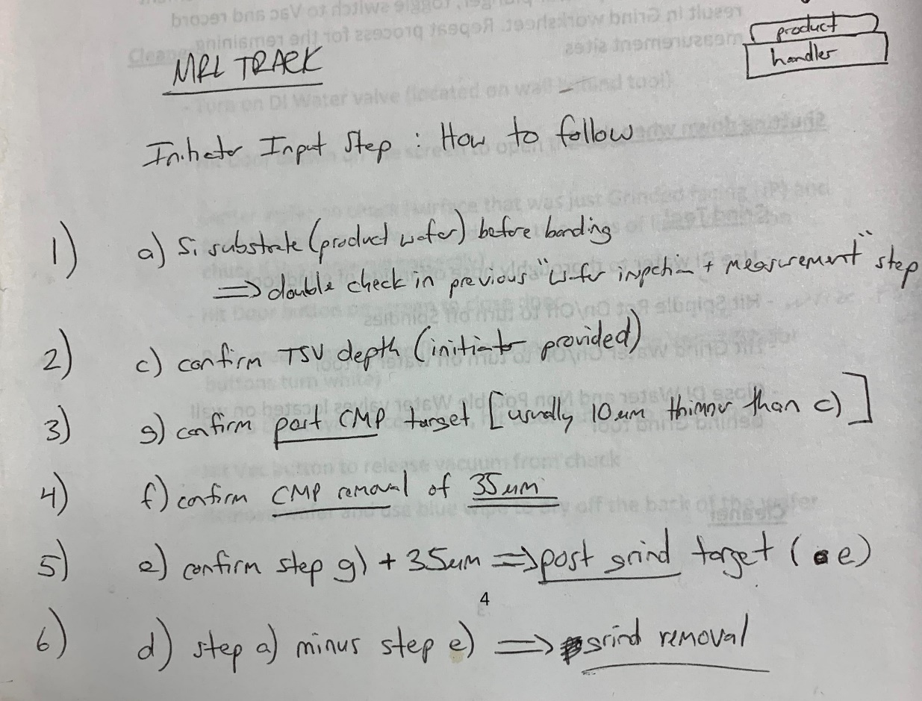

Product wafer Processing

- Pre-measure product wafer on granite table (see procedure below)

- Select List

- Highlight Recipe 5 : Step 1 Course_Bond

- Click select to activate Recipe 5

- Input Original Thickness and **Removal Amount** (value d) according to MRLTRACK), then hit Save (for recipe #5)

- Hit Workset, then Spindle On/Off and Grind Water On/Off to turn the spindles and water on

- Hit Chuck Blow On/Off on, then off.

- Put wafer in center of chuck (surface to be polished facing UP – if the wafer has been trimmed, that is the side you want to grind. The handler wafer should have the wafer ID that is in MRL TRACK)

**\*\*\*\*\*\*\*\*\*\*\*\*\*\*\*\*\*\*\*\* DO NOT GRIND the handler wafer \*\*\*\*\*\*\*\*\*\*\*\*\*\*\*\*\*\*\*\*\*\***

- Hit Chuck Vac On/Off to turn vacuum on.

- Hit Workset and then Start

- Write down incoming thickness (IPG: Work Thik) and time from grind tool in notebook/Grind worksheet.

- At end of cycle write down the Post Grind thickness, then hit Alm/Clr button

- Use DI water to hose off the inside of the tool as well as the wafer on the chuck

- Hit Chuck Vac On/Off to turn off the vac, then hit Chuck Blow On/Off and remove wafer. Rinse the back side of it off with DI water, as well as the chuck.

- After wafer has sufficiently dripped dry, place in cleaner

- Post-measure the product wafer on granite table (see procedure below)

**Cleaner**

- Turn on DI Water valve (located on wall behind tool)

- Hit Door button on the screen to open the door

- Center wafer on chuck (surface that was just Grinded facing UP); push Vac button (wafer should have two rings of lines visible on chuck if it is centered correctly)

- Hit Door button on screen to close door

- Push green start button (hold for a few seconds til PRG#, WSIZE, and FSIZE values turn white)

- When clean cycle is complete, hit Door button to open door

- Hit Vac button to release vacuum from chuck

- Remove wafer and use blue wipe to dry off the back of the wafer

**Wafer Thickness Measure Tool**

- Turn on Vacuum (valve located on wall in back of tool)

- Turn on Nitrogen (valve located on wall in back of tool)

- Toggle switch to Nitrogen, place wafer on tool, lift plunger and move wafer to desired measurement location (hold on to wafer as it will float across tool with Nitrogen toggled on). **Then slowly lower plunger.**

- Toggle switch to Vac to turn on vacuum

- Press down lightly around probe to measure more accurately

- Measure wafer and record result in Grind worksheet

- Toggle switch to Nitrogen, lift plunger, move to next measurement location, slowly lower plunger, toggle switch to Vac and record result in Grind worksheet. Repeat process for the remaining measurement sites

**Shutting down when done**

**Grind Tool**

- Use DI water to thoroughly hose off inside of grind tool

- Hit Spindle Rot On/Off to turn off Spindles

- Hit Grind Water On/Off to turn off water in tool

- Close DI Water and Non-Potable Water valves located on wall behind Grind tool

**Cleaner**

- Close DI Water valve for cleaner (located on wall behind cleaner)

- Hit Door button to close door

**Wafer Thickness Measure Tool**

- Put dummy wafer under plunger on Wafer Thickness Measure Tool and measure wafer thickness. Compare the reading to the value on the wafer to ensure the measure tool is operating properly

- Close Vacuum valve and Nitrogen Valve (both located on wall behind Wafer Thickness Measure Tool)

- Toggle switch to the Release position on the Wafer Thickness Measure Tool

- Shut Gauge Off